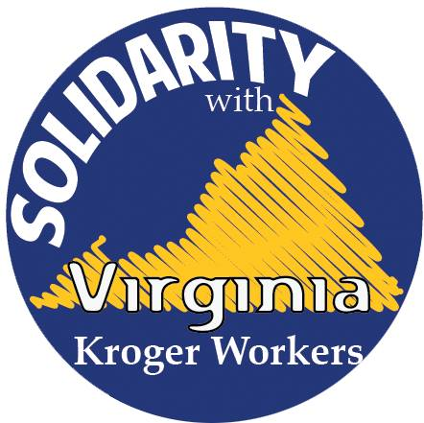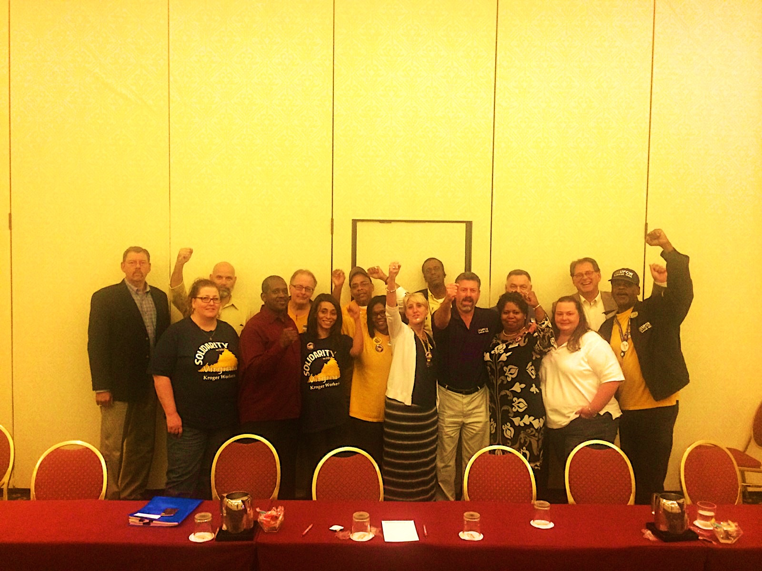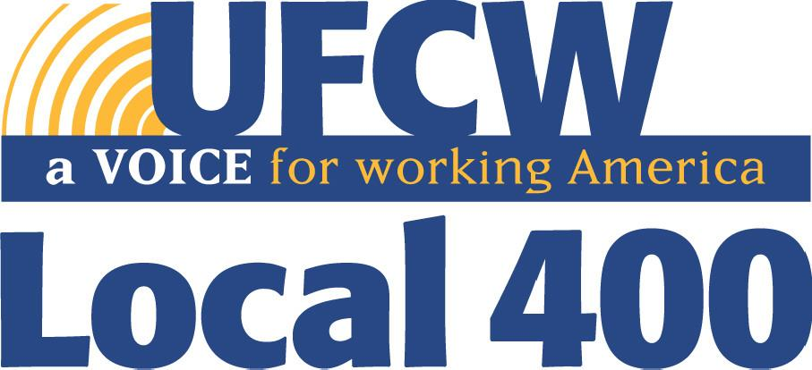

Join us! Sign up to fight back! Contact your shop steward or representative at:

**Sterling: 301-459-3400 ext. 289**

**James: 301-459-3400 ext. 202**

**A Message From Your Bargaining Committee**

After months of hard work, we have reached a tentative agreement with Kroger for a new contract. It took many hours at the negotiating table, wearing buttons and stickers, attending rallies, and getting support from our customers and community, but we feel we have gotten the best possible deal for all of us.

“It took us working past the original expiration date, but I’m proud of my coworkers, fellow bargaining committee members, and the leadership of our union, we fought hard and are proud of the agreement we have reached,” said Michael Holcomb, a committee member from store 512 in Richmond.

Be on the look out for information about contract meetings, which will be held before the end of the month. At these meetings you will have the opportunity to hear details of the tentative agreement, ask questions, and vote on the proposal. **You have to be a member to attend and vote – so sign up now!**

**Tentative**

**Contract AgreementReached**