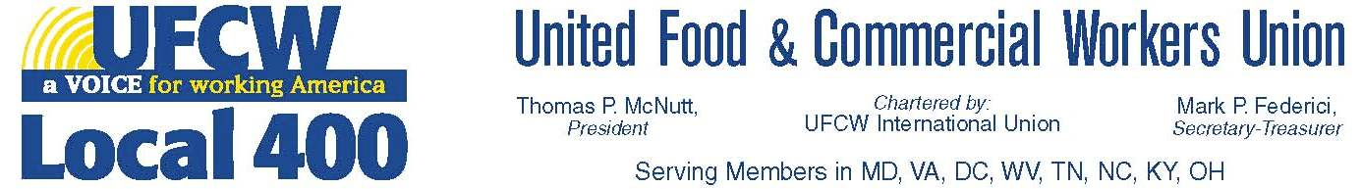

SAFETY CHECKLIST FOR GROCERY STORES

STEWARD---- STORE NUMBER---

DATE--- TIME---

1) FIRE EXIT UNBLOCKED AND PROPERLY SIGNED---

2) FIRE LANES—

3) UNSAFE FLOOR HAZARDS--- ( SLIP HAZZARDS, DEFECTIVE TILES ETC.)

4) FREEZER AND COOLER DOORS--- (CHECK INSIDE AND OUTSIDE HANDLES, CLERANCE FOR OPENING)

5) ELECTRIC PANELS---(NOTHING BLOCKING ACCESS)

6) ELECTRICAL OUTLETS AND BOXES---(CHECK MISSING COVER OR EXPOSED WIRES)

7) EYE WASH STATIONS--- (UNBLOCKED AND WATER PRESSURE)

8) UNBLOCKED MAIN SPRINKLER CONTROLS---

9) PROPER STORAGE OF HELIUM TANKS----

10) BROKEN EQUIPMENT----

11) COOLER AND FREEZER (STORAGE ON TOP) UNLESS REINFORCED TO WEIGHT LOAD LIMITS—

12) FIRE EXTINGUISHERS MOUNTED PROPERLY TO CODE--

13) WATERPROOF COVERS AND GFI OUTLETS IN WET AREAS

14) PROPER COATS JACKETS AND RAINGEAR

15) PROPER STORAGE OF PROPANE TANKS

16) PROPER FIRST AID KITS –(CHECK DATES)

17) OSHA APPROVED SKID MATS IN WET AREAS

20) PROPER STORAGE OF KNIVES IN PREP AREAS---

21) SANITARY CONDITIONS—

1. RESTROOMS
2. BREAKROOMS
3. WORK AREAS

22) GENERAL HOUSEKEEPING, FIRE VIOLATIONS

NOTES—

**UFCW LOCAL 400 LEADING THE WAY IN SAFETY EDUCATION**

**COPYRIGHT 2012 U.F.C.W. LOCAL 400 All Rights Reserved - Contact Chuck Miller**